Image | 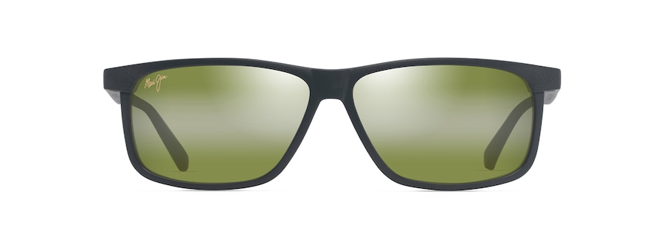
Brand | MAUI JIM
Model Name | PŪLAMA
Price | RS 2890
PRODUCT DETAILS

